Decision GPS Version 5

Decision Graph - Functional Specifications

# Document reference: R5-FS-DG v0a

**R5**: The *Decision GPT R5* is the first version integrating Decision Graphs.

**FS**: Functional Specification. This document does not describe the technical implementation. Instead, it focuses on the algorithm and usage of the decision graphs.

**DG**: Decision Graphs. This is the new functionality being described.

**V0a**: Version Zero of the document. Version zero is the first draft. Odd numbers are for work-in-progress versions of the document. Even numbers are for stable versions that can be shared with developers and QA testers.

For work-in-progress versions, a letter is added to differentiate the updates. The very first draft of a document is then V0a.

# Document Purpose

The Decision Graphs are an advanced feature of the GPS version 5. It combines a P&L graph and a Target Graph to monitor the performance of the factor against a target value at a specified date in the future, with the Decision Confidence being the third layer of the Decision Graph, complementing the subjective degree of decision ownership to the timeline.

All three graphs' timelines are identical, start at the factor creation date, and end at the target date specified in step 1.

This document explains the P&L and Target Graphs algorithm, how to enter the target date and value in step 1, as well as the usage of the transaction table to feed the P&L graph.

# Document Versions

|  |  |  |
| --- | --- | --- |
| Version | Updates | Author |
| V0a | Document Creation | C. Rossello |
| V1 | Document Validation | M. Schuller |

# General Context

Decision graphs' usage and benefits are not self-explanatory. It is important that the user fully understands how these three graphs are being built to avoid misinterpretation or frustration with empty graphs.

Note: The three graphs are duplicated in the Dashboard and the Report Card.

# Data input

## Target date

In step 1, use the input field *Target Date* and the built-in calendar to select a target date for the factor. To build realistic graphs, this date should not be too far in the future, nor too close to the factor creation date, to create a timeline. The Target Date represents the estimate of the user until when the investment hypothesis will have been materialized.

## Target value

In step 1, use the input field *Target Value* to enter a targeted value of the indicator that will be displayed in the Target Graph.

## Target Indicator

In step 1, select first the Indicator Family, then enter at least three characters of the indicator ticker or name. Finally, select the desired indicator from the dropdown list titled *Target Indicator*.

Note: This information is saved with the step 1 panel. In case of an update, all factor’s steps must be re-saved.

# Target Graph

The Target graph compares the security specified in step 1 with the target value specified in step 1 as well. It displays the value evolution of the Target Indicator’s End-of-Day value between the factor creation and the present day. The graph's total timeline extends to the Target Date.

The Target value, a constant, is displayed as a green flat line.

The objective for the user is to have the Indicator value as close as possible to the Target value at the Target date.

# P&L graph

The P&L graph is more complex than the Target graph.

The P&L graph sums up the individual P&L of all the registered transactions associated with that factor.

## P&L from closed transactions

The final P&L of a closed transaction after its Close date = *(Close Price – Initial Price) * quantity*.

Its P&L between the Entered date and the Close date = *EOD value * quantity*.

The P&L is applied to all days between:

* the most recent of the factor’s Creation date and the Transaction Starting date.
* The closest in the future of the Transaction Close date and the Target date.

## Example of a closed transaction

Factor creation date: 26 June 2025, Target date: 19 September 2025





Transaction entered on 15 July 2025, closed on 25 July 2025.

Result on the P&L graph with three periods:

* Factor creation to transaction entered: **P&L = 0**
* Transaction entered to transaction closed: **P&L = (EOD value – initial Price) * quantity**
* Transaction closed to Target date: **P&L = (Close price – Initial price) * quantity**

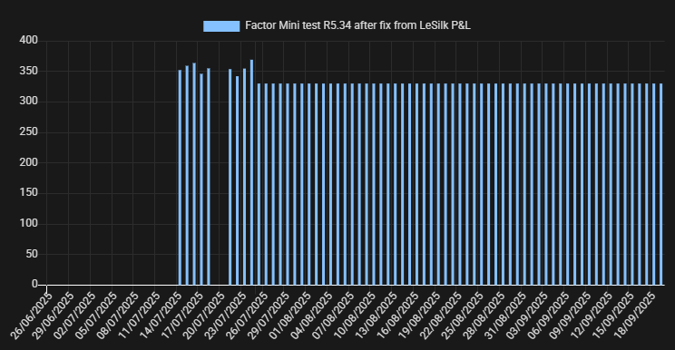

## P&L from open transactions

Factor creation date: 26 June 2025, Target date: 19 September 2025





Transaction entered on 18 June 2025

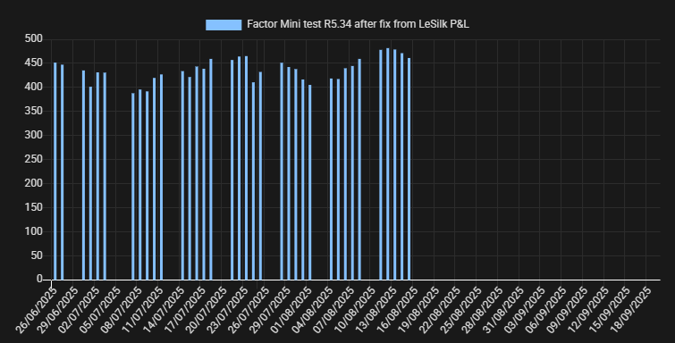

From the factor’s creation date to the present day: **P&L = (EOD value – initial Price) * quantity**

## Factor’s P&L

P&L graph with the two transactions:  
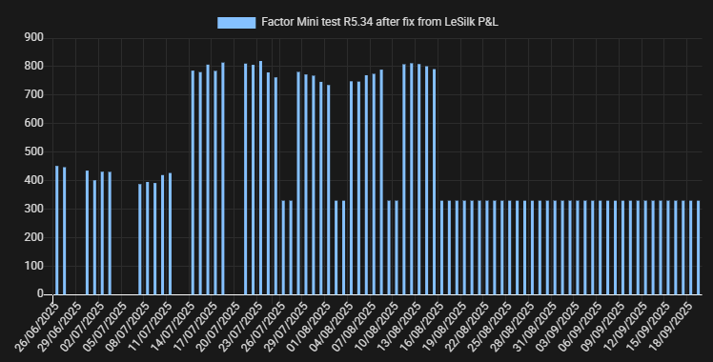

## Short Vs Long transactions

In the case of a short transaction, its P&L is inverted before being summed up to the factor’s P&L.

Example with the same close transaction:

